Call for Papers: IJAET, Volume 6 – Issue 1
International Journal of Advances in Engineering & Technology
ISSN: 2231 – 1963
Deadline : 31th January 2013
Notification : 15th February 2013
Revision : 20th February 2013
Publication : 01st March 2013
Smooth, simple and timely publishing of review and research articles!
IJAET welcomes research articles from scientists, Engineers and Research Scholars involved in all areas of engineering and technology from all over the world to publish high quality research papers. Papers for publication in the IJAET are selected through rigorous peer review to ensure originality, timeliness, relevance, and readability.
IJAET is inviting fresh submissions for its forthcoming issue, Volume 6, Issue 1. Authors are encouraged to contribute their original research to the journal by submitting their research papers that comes under any of following category: research findings, projects, literature surveys, review works, case studies, short communications of high quality, theoretical or empirical research articles, book reviews, proposals, analysis, tutorials, editorials as well as pedagogical and curricular issues that describe significant advances in field of Engineering and Technology.
For list of IJAET topics visit, aim and scope (http://www.ijaet.org/aim-scope-of-ijaet/index.html)
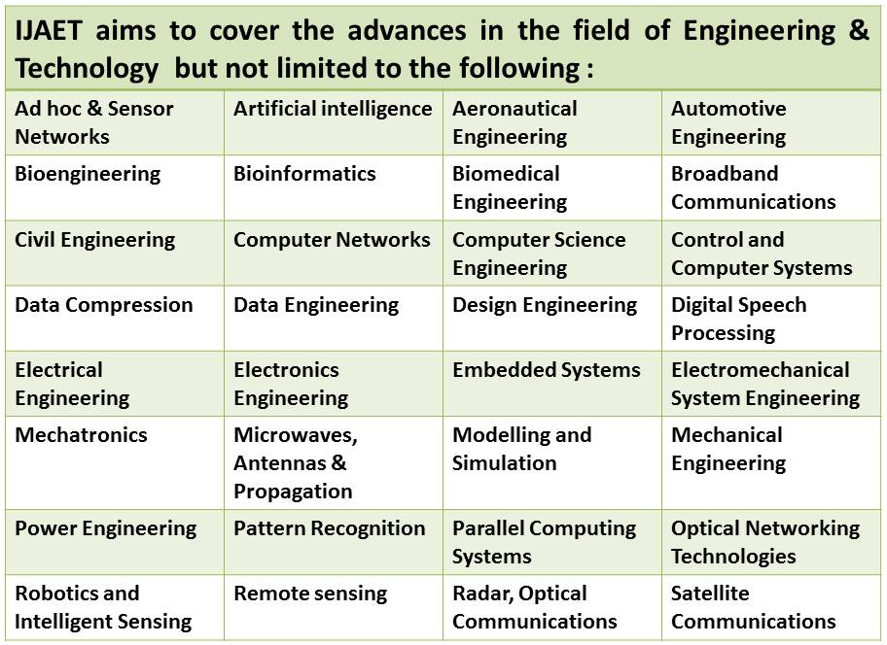
All submitted papers would be evaluated through a peer-review process conducted by the editorial board of IJAET. For editorial workflow for the peer review process of IJAET visit (http://www.ijaet.org/peer-review-of-ijaet/index.html)
The following play a major role in disseminating IJAET data.
http://www.squidoo.com/international-journal-of-advances-in-engineering-and-technology
http://ijaet.academia.edu/EditorIJAET/Posts
http://www.ijaet.org/call-for-paper-of-ijaet/index.html
http://www.cfpinternationaljournal.com/
http://www.prolearn-academy.org/Members/editor_ijaet/IJAET-2013
http://www.callforpapers.biz/ijaet.html
http://www.prolearn-academy.org/Members/editor_ijaet/CallForPapersIJAETJanIssue
www.callforpapers.biz/cfp-list.html
http://www.wikicfp.com/cfp/servlet/event.showcfp?eventid=24800
http://in.linkedin.com/groups/IJAET-Journal-4654769
http://www.callforresearchpapers.com/
http://www.academia.edu/2329168/Call_for_Papers
https://groups.google.com/group/ijaet-journal?hl=en
http://www.prolearn-academy.org/Members/editor_ijaet/Call%20For%20Papers%20IJAET
http://www.call-for-papers.org
http://ijaet.com/call_for_paper_ijaet.html
http://www.prolearn-academy.org/Members/editor_ijaet/call-for-papers-international-journal-of-advances-in-engineering-technology
https://docs.google.com/file/d/0B54N5ws75W5TdHlNY2d0dzU3bFE/edit?pli=1
http://hastac.org/opportunities/call-papers-international-journal-advances-engineering-technology
http://www.wikicfp.com/cfp/servlet/event.showcfp?eventid=15433
http://www.callforpapersjournals.com/
http://www.ijaet.info/call_for_paper.html
http://ijaet.blogspot.in/
http://www.prolearn-academy.org/Members/editor_ijaet/CFP%20IJAET%202013
It is appreciated if you could share this information with your colleagues and associates. Thank you.
URL: http://www.ijaet.org
E-mail: editor@ijaet.org

